Wishing you a very



and a peaceful and joyous
New Year!

Best wishes from all at
St. Columba’s United Reformed CHURCH

Seasonal Events and Services

Dec 3rd- Advent Communion, 10.15 am
Dec 10th- Mission Partners Service, 10.15 am
Dec 17th-All Age Service, 10.15 am
Dec 18th-Micklegate Mingle from 5-8 pm – join us for hot drinks, mince pies, and carols!
Dec 23rd-Open Air Carol Service outside St. Martin’s on Coney Street; hot drinks available.
Dec 24th-Service of Lessons & Carols, 10.15 am
Christmas Eve Communion, 6 pm
Dec 25th-Christmas Worship at 10.15 am

The church will be open every weekday from December 4-22 from 12-2 pm for prayer, reflection, and hot drinks.

St. Columba’s URC
32 Priory Street, YO1 6HA
Minister: Rev'd Alison Micklem
tel: 01904 488291 e-mail: micklem@clara.co.uk
Time for God Volunteer: Katie Golden
Email: Katiestcolumbas@gmail.com
For more info, visit our website yorkurc.org.uk or find us on Facebook at https://www.facebook.com/StColumbasYork/
Look out for our community events in the New Year!

ALL FREE AND OPEN TO THE PUBLIC!

Tuesdays: Join us for weekly Coffee Mornings from 10.30 am-12 pm & Weekday Worship 12-12.30 pm.

Wednesdays: Join us every week for our Crafts with a Cause group starting January 3rd from 1-3 pm. Seniors 60+ and their carers are invited to make crafts that will benefit charities or be sold to benefit groups in need; tea and coffee provided.

Fridays: Join us on the last Friday of each month for our Community Lunches. All are welcome!

Saturdays: Join us for Organ Concerts on Saturdays, January 6th, 13th, 20th, and 27th and February 3rd and 10th, and other concerts throughout the year.

Sundays: Join us at 10.15 am for Worship, with coffee and tea after. Students and other young people are invited to our Student Night at 6.30 pm.

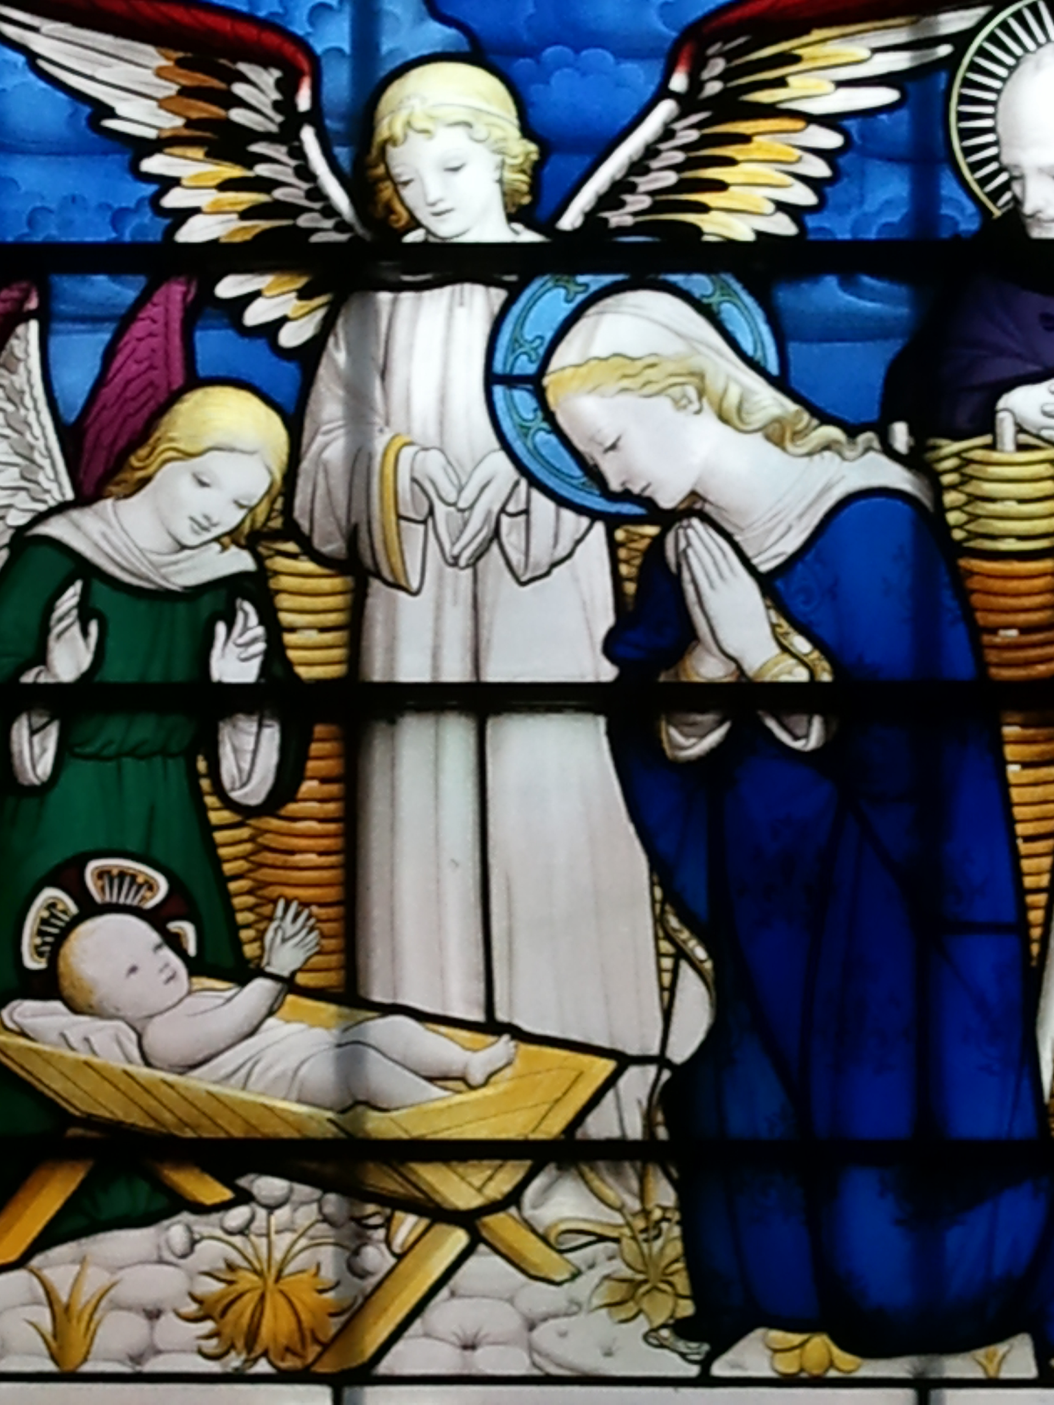
Photo from the Nativity Window at St. Columba’s URC

